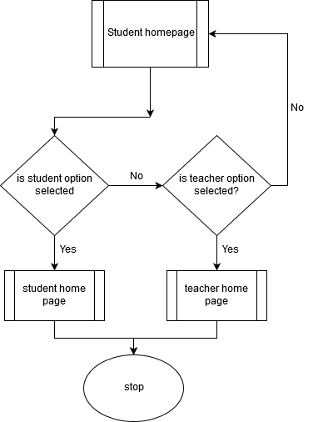

*Flow chart 1 : the outline of the whole soft ware.*

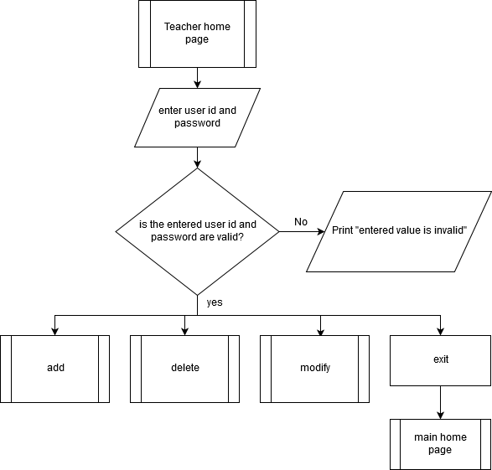

*Flow chart 2 : the outline of the whole teacher page.*

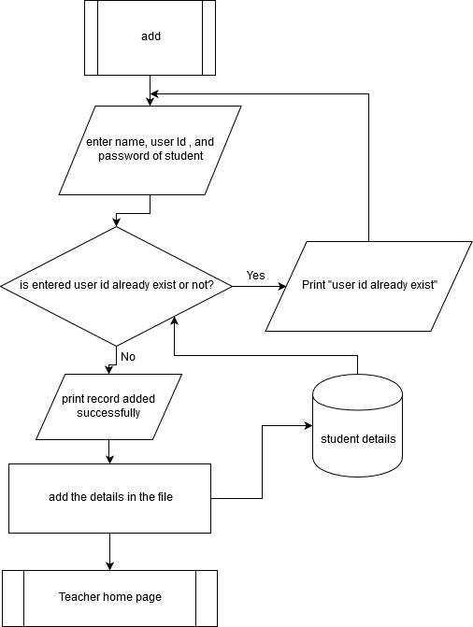

*Flow chart 3 : the outline of the add option.*

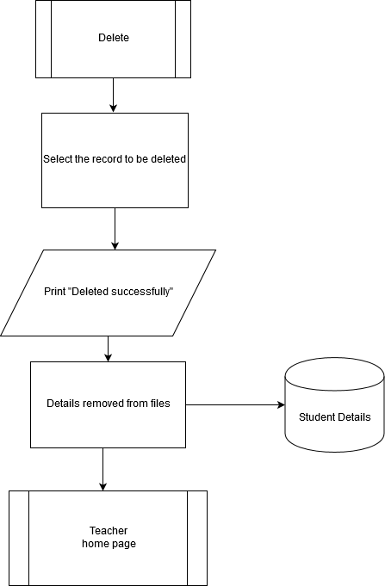 *Flow chart 3 : the outline of the delete option.*

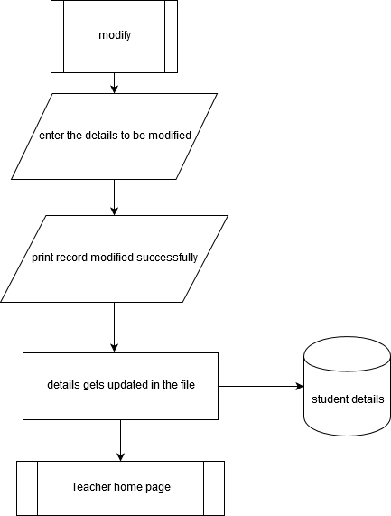

*Flow chart 3 : the outline of the modify option.*

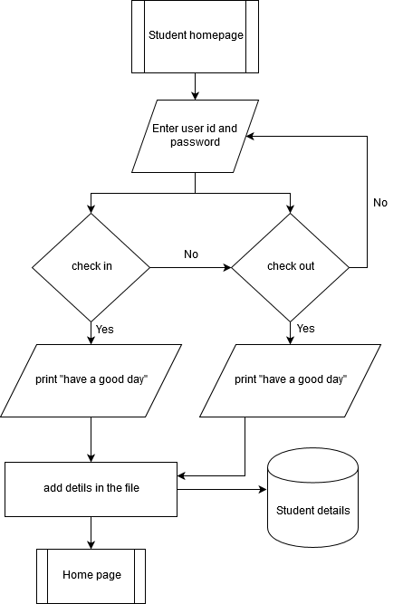

*Flow chart 3 : represents the working outline of the student page.*

UML Diagrams:

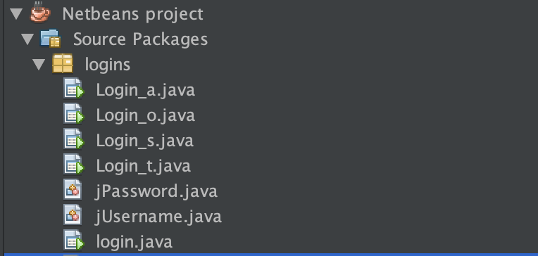

UML diagram 1 : Class Diagram

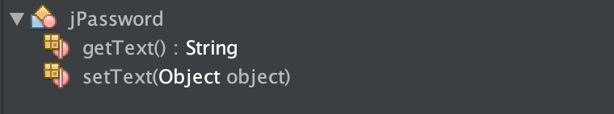

UML diagram 2 : jPassword

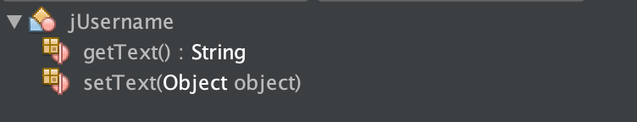

UML diagram : jUsername

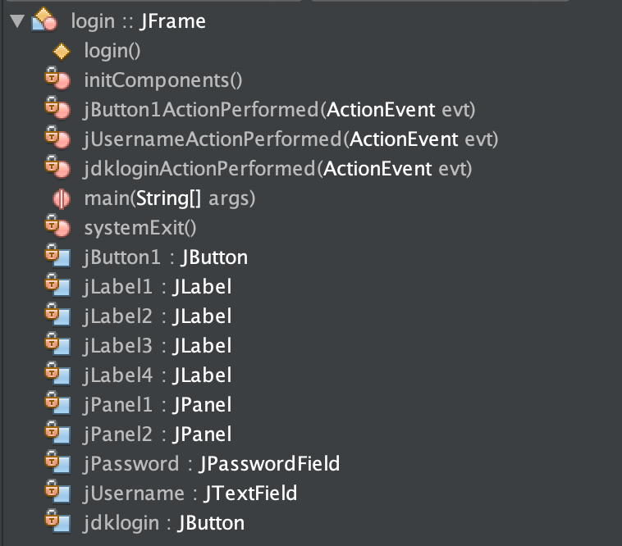

UML diagram 4 : Login

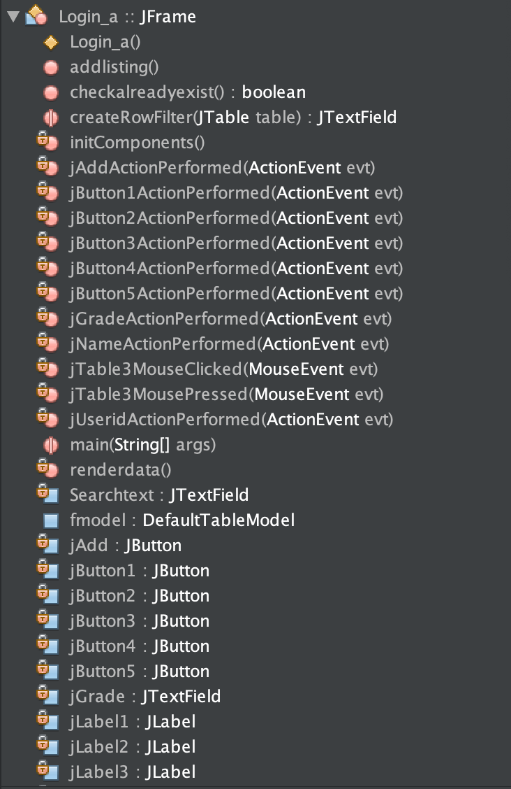

UML diagram 5 : Login_a 1

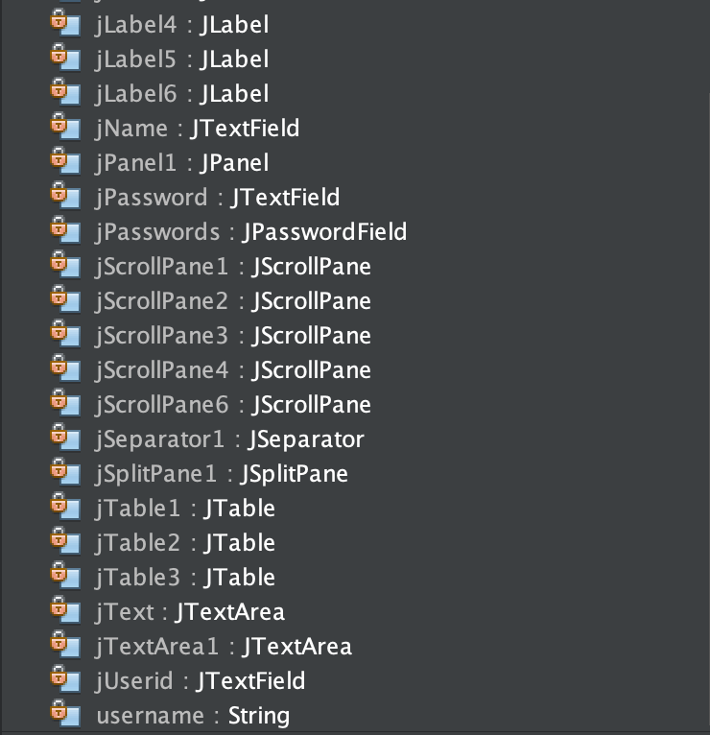

UML diagram 6 : Login_a 2

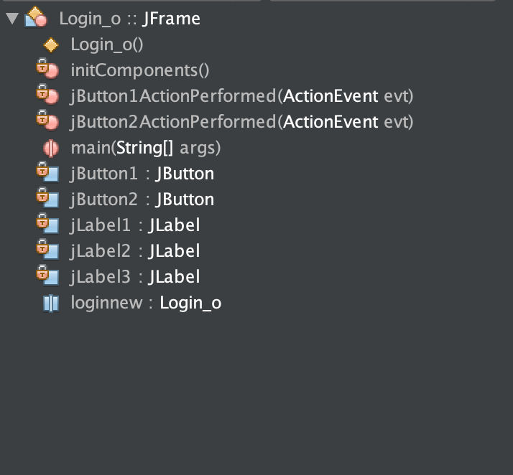

UML diagram 7 : Login_o

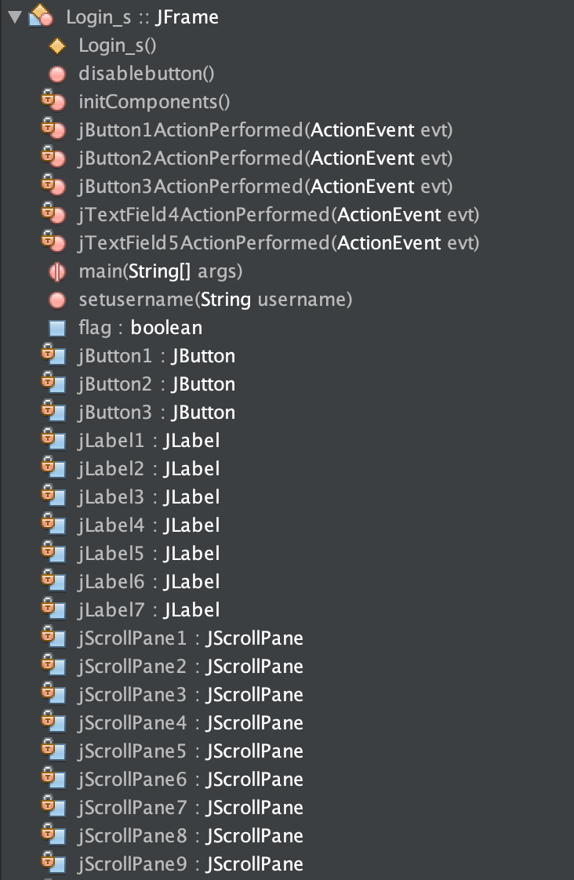

UML diagram 7 : Login_s 1

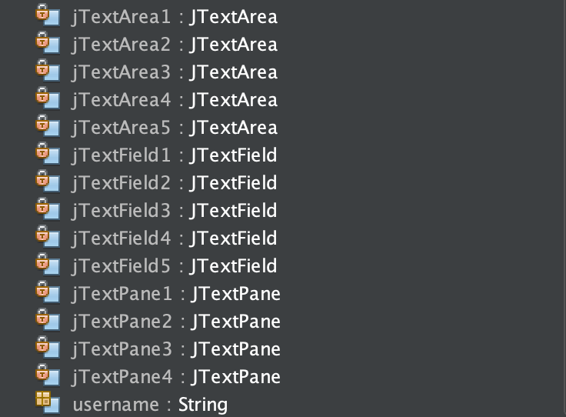

UML diagram 8 : Login_s 2

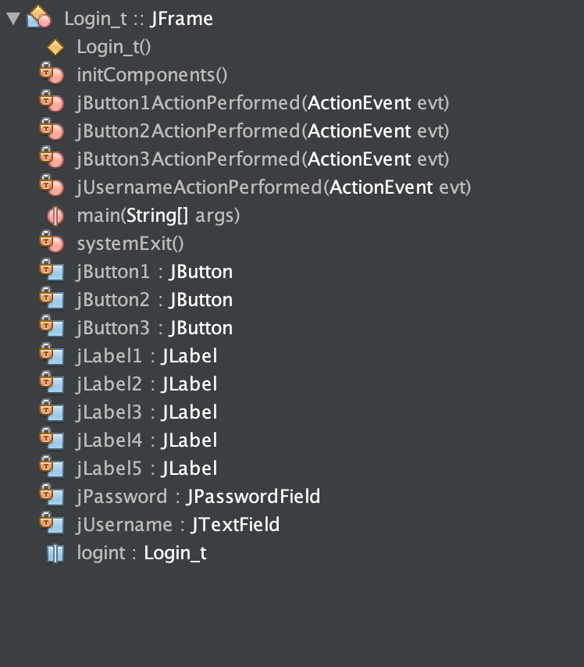

UML diagram 9 : Login_t

Test plan

|  |  |
| --- | --- |
| Success criteria | Test plan |
| Error message when empty cells are entered | Enter empty cells and check if error statement pops up. |
| Error message when wrong pass or user id is entered | Enter wrong password or user id and check. |
| Creation of multiple student accounts with the same user id | Create many accounts with same user id and see if error statement is displayed or not |
| Delete and see if only the selected student account is deleted or all are deleted. | Select the cell and delete and see. |
| See if the modifications are successfully modified | Use a pop up which displayes ‘successfully modified’ if the entered is successfully updated. |
| See if check in is successfully registerd when you click check in once. | Use a pop up that pops up once the student selects check in once. It must display user friendly message like “have a nice day” with ok button which will redirect student back to student page. |
| See if check in is successfully registerd when you click check out once. | Use a pop up that pops up once the student selects check in once.. It must display user friendly message like “good bye” with ok button which will redirect student back to student page. |
| going back to home page directly instead of closing and opening the program each time. | Add exit button to every pages which will redirect the user to main login page. |
| Check if the program works with every operating system. | The program was shared with my friends to see if successfully runs on their laptop. |
| Check if there is data loss when information is shared and check if the entered data succefully gets stored. | The program was shared with my friends as a zip file and was run on their laptop and it was made sure no data loss takes place. |